SDLC – Software Development Life Cycle
Introduction
The Software Development Life Cycle (SDLC) is a structured approach used by software teams to plan, design, develop, test, deploy, and maintain software applications. It ensures that a project moves through organized stages, helping developers deliver high-quality solutions that meet user expectations. SDLC provides clarity, reduces risks, improves communication among teams, and ensures the final product is stable, secure, and efficient.
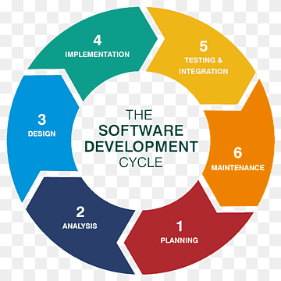

1. Requirement Gathering and Analysis
This is the first and most important phase of SDLC. The goal is to understand exactly what the client or end-user needs from the software.
Key Activities
- Meetings with the Product Owner (PO), stakeholders, and sometimes clients.
- Collecting functional and non-functional requirements.
- Preparing documents such as SRS (Software Requirements Specification) and wireframes.
- Understanding system goals, constraints, and user expectations.
The requirement document becomes the base for the design and development phases. Clear requirements reduce errors later and save time, effort, and cost.

2. Technical Documentation / System Design
Once requirements are finalized, the technical team—Architects, Technical Leads, and Senior Engineers—plan the structure of the application.
Key Activities
- Designing overall system architecture (layers, modules, interactions).
- Identifying classes, interfaces, components, inheritance, and reusable modules.
- Preparing diagrams such as ER diagrams, class diagrams, flow diagrams, and sequence diagrams.
- Selecting the technology stack for frontend, backend, and database.
- Reviewing the design multiple times to ensure scalability and maintainability.
The output of this stage is a Technical Design Document (TDD), which acts as a guide for developers during implementation.

3. Coding / Development Phase
This is the most active phase where actual software creation begins.
Key Activities
- Developers (SE, SSE, or Leads) write clean, structured, and optimized code.
- Follow coding guidelines, naming conventions, and project standards.
- Perform unit testing of individual modules.
- Use version control systems like Git for managing code.
At the end of this phase, a working version of the software is ready to be handed over to the QA team for testing.

4. Testing Phase
Testing ensures that the developed software functions correctly and meets all requirements. The QA (Quality Assurance) team plays an essential role here.
Key Activities
- Deploying the build on a QA server.
- Performing functional, integration, system, regression, and performance testing.
- Identifying issues and raising bugs using tools like JIRA or Azure DevOps.
- Working with the development team to fix and verify bugs.
The goal is to provide a stable and error-free build that can move into staging and user acceptance testing environments.

5. Staging / UAT (User Acceptance Testing)
Before releasing the software to the production environment, it is tested in staging or UAT.
Key Activities
- Regression testing to ensure old features still work.
- Load and stress testing to check performance under pressure.
- Running automation test cases if available.
- Client or business teams perform UAT to verify real-world requirements.
Once UAT is approved, the software is ready for live deployment.

6. Production Deployment
This phase involves releasing the final build to the Production Environment (PE) and making it available to actual users.
Key Activities
- Deploying the application in the live environment.
- Monitoring the system to ensure proper functioning.
- Resolving post-deployment issues or immediate hotfixes if required.
This phase marks the Go-Live, where the software becomes fully operational.

7. Maintenance and Bug Fixing
After deployment, the software enters the long-term maintenance stage.
Key Activities
- Fixing user-reported bugs and issues.
- Releasing updates and enhancements over time.
- Monitoring system health, performance, and security.
- Keeping documentation updated with every change.
Maintenance ensures the software continues to meet business needs and remains up-to-date with technology changes.

Conclusion
SDLC provides a disciplined and organized approach to software development. By moving through clearly defined stages—requirements, design, coding, testing, staging, deployment, and maintenance—teams can create reliable and high-quality software products. Each phase builds on the previous one, ensuring smooth coordination, improved efficiency, and successful project delivery. A well-followed SDLC not only helps avoid costly mistakes but also ensures long-term stability and user satisfaction.

